ucbadmit |>
count(dept, gender, admit) |>
print(n = 50) |>
kbl() |> kable_minimal()
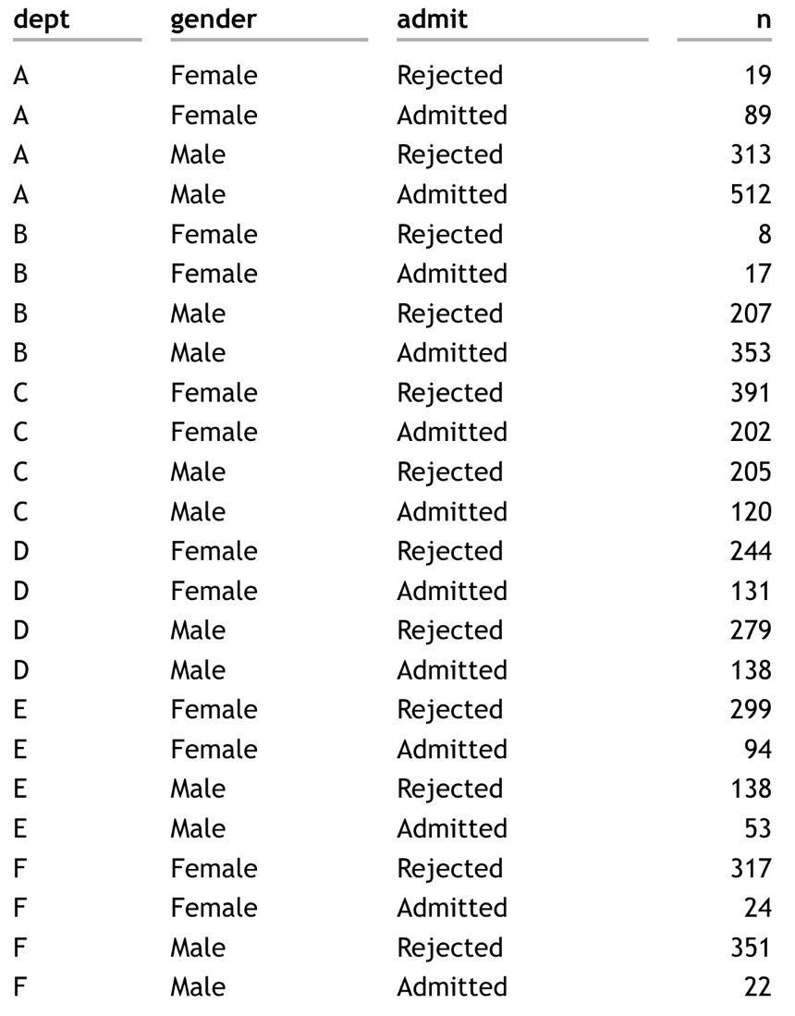

- What can you add on to the ucbadmit |> count(dept, gender, admit) pipeline to compute the proportions accepted/rejected for each gender x dept combination?

- How many rows and columns will result from the following code?

ucbadmit |>
group_by(dept, gender) |>
summarize(prop_admitted = sum(admit == "Admitted")/n())

- What code would produce the following table?

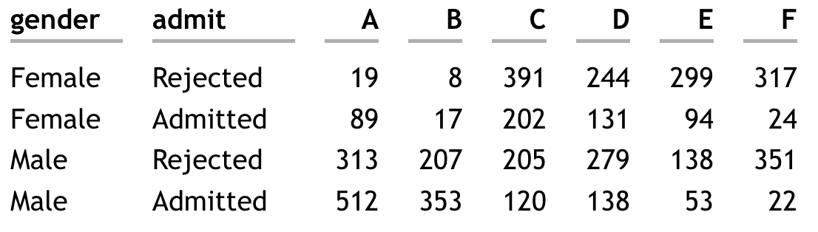

- What code could you add to a ucbadmit |> count(dept, gender, admit) pipeline to produce the following table. Note, this may require several steps.
- 